AARON BALABABA
BSIT 4-1 PUP-RAGAY (eronbalababa@gmail.com)
WhatNext Vision Motors: Shaping the Future of Mobility with Innovation and Excellence

WhatsNext Vision Motors, a pioneering force in the automotive industry, is dedicated to transforming the mobility sector with innovative technology and solutions that prioritize customer needs. The company has embarked on an ambitious Salesforce project with the core objective of enhancing the customer experience and streamlining its operational processes.
At the heart of this project is the improvement of the customer ordering process. The system is designed to automatically suggest the nearest dealer location to customers based on their address. This feature is intended to significantly enhance the convenience and efficiency of the ordering experience, making it more customer-friendly and reducing the time and effort required from the customer's end.
The project also addresses a common issue in the automotive industry: stock availability. The system includes a mechanism that prevents customers from placing orders for vehicles that are out of stock. This proactive approach ensures that customers can only create orders for vehicles that are currently available, thus avoiding potential confusion and disappointment that may arise from stock unavailability. This feature not only enhances customer satisfaction but also improves the accuracy of the company's order fulfillment process.
Furthermore, the project incorporates a scheduled process for updating the status of bulk order records. This automated process is designed to update the order status based on stock availability. If a vehicle is out of stock at the time of order placement, the system will update the order status to 'Pending.' On the other hand, if the vehicle is in stock, the system will update the status to 'Confirmed.' This ensures that all orders are accurately reflected in terms of their fulfillment status, providing clear and transparent communication to customers regarding the status of their orders.
The implementation of this Salesforce project at WhatsNext Vision Motors is expected to yield several benefits. It aims to create a more efficient ordering system that reduces the potential for errors and improves the overall service provided to customers. By streamlining the ordering process and ensuring accurate stock availability, the company can enhance customer satisfaction and loyalty.
Moreover, the project is expected to contribute to operational efficiency by reducing the administrative burden on staff. By automating certain processes, employees can focus on more strategic tasks that require human intervention and expertise. This not only improves the overall productivity of the company but also allows for a more agile response to market demands and customer needs.
Data Management-Objects
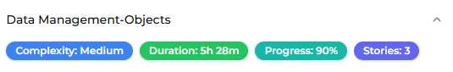
Vehicle Customer
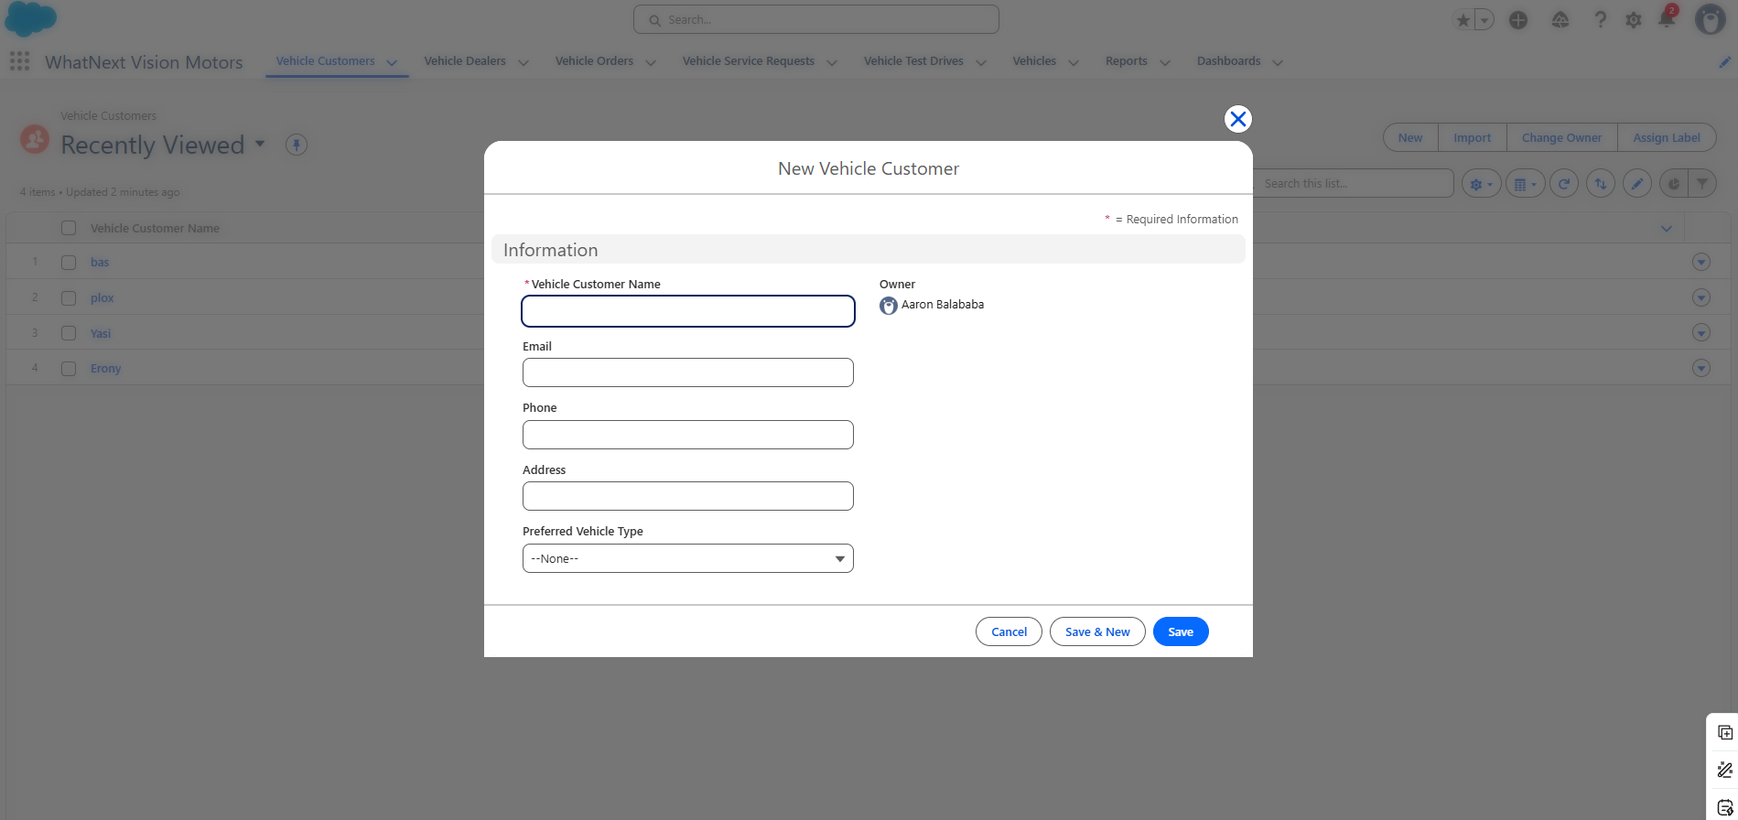
Vehicle Dealers
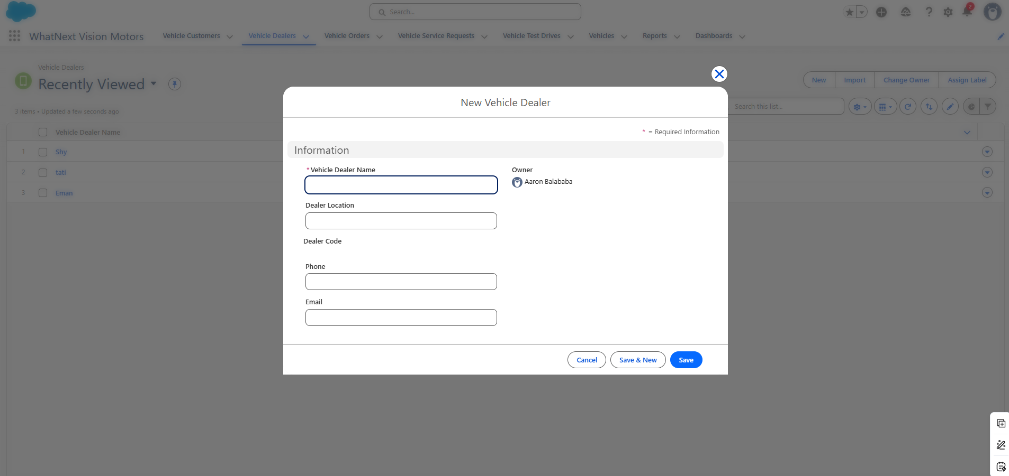
Vehicle Orders
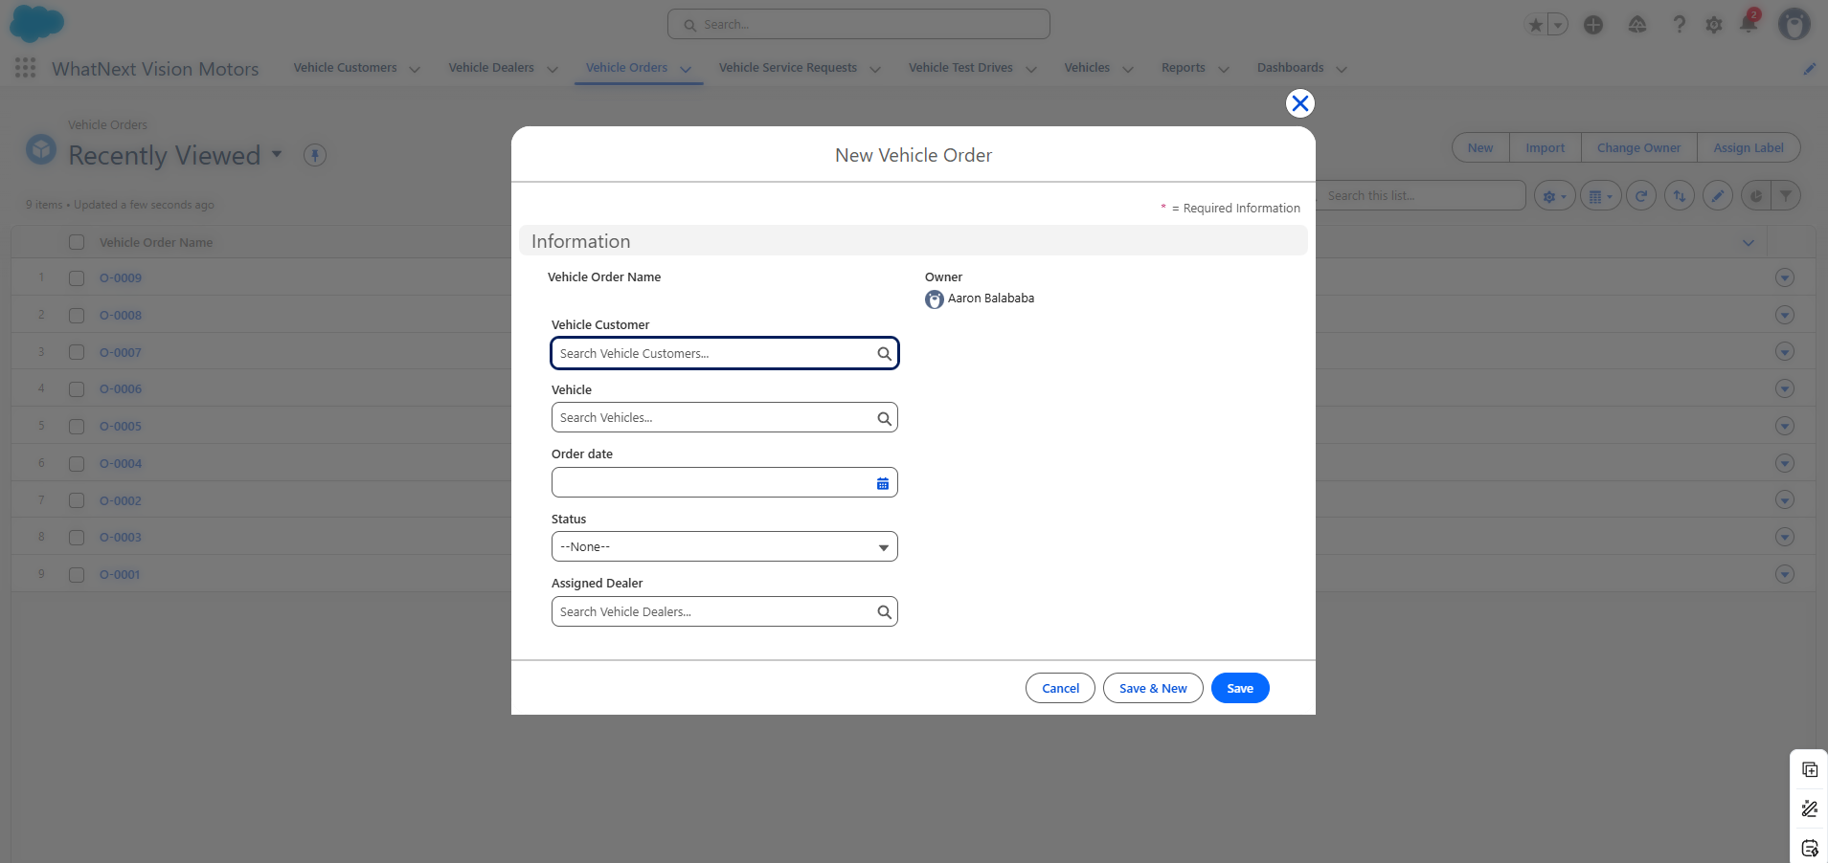
Vehicle Request
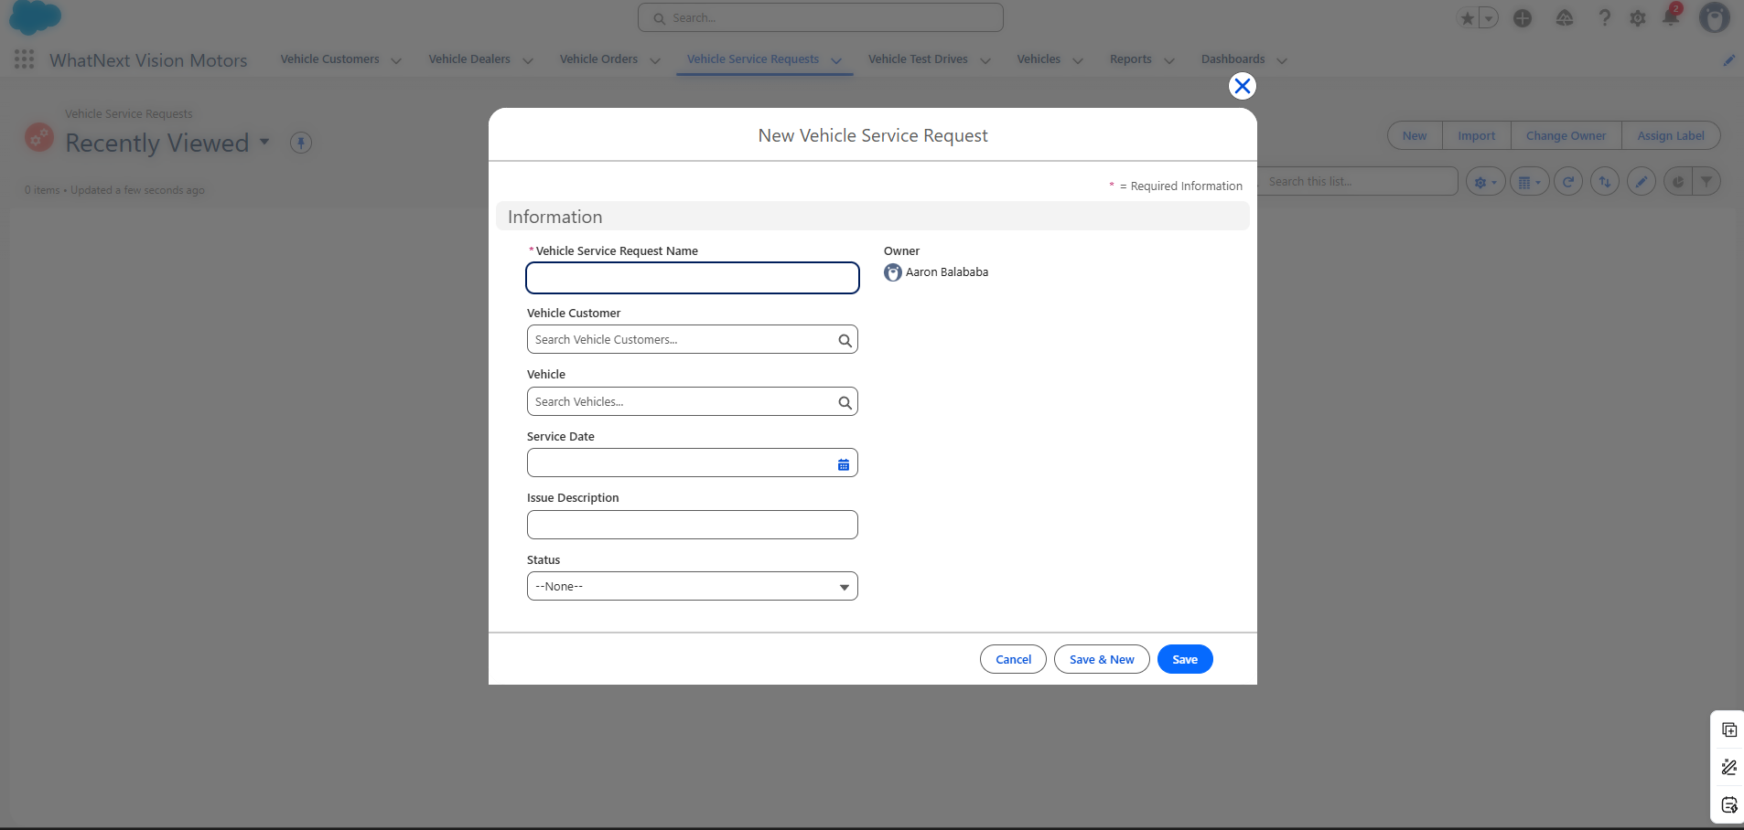
Vehicle Test Drives
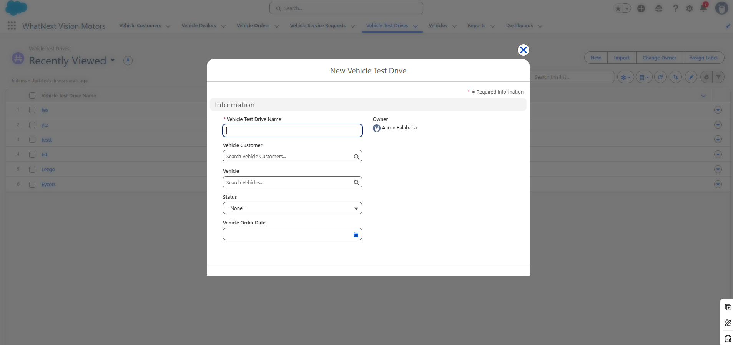
This feature would Tell the client if they have an upcoming test drive based on their email information and will be sent to them as a reminder and if they would like to cancel or reschedule

Vehicles
